**R.V. College of Engineering, Bengaluru**

**(Autonomous Institution Affiliated to VTU, Belagavi)**

**Department of Electronics and Communication Engineering**



**4rd Semester**

**Self-Study Report**

**TRAFFIC CONTROLLER AND FINDING DAY FROM GIVEN DATE**

Group Members: USN Signature

1. Rohit Veeradhi 1RV17EC178
2. Varsha Kulkarni 1RV17EC177
3. Vajra Singh 1RV17EC176

Class incharge signature :

Date:

**INTRODUCTION**

**TRAFFIC CONTROLLER**

Road traffic control involves directing vehicular and pedestrian traffic around a construction zone, accident or other road disruption, thus ensuring the safety of emergency response teams, construction workers and the general public.

The normal function of traffic lights requires more than slight control and coordination to ensure that traffic and pedestrians move as smoothly, and safely as possible. A variety of different control systems are used to accomplish this, ranging from simple clockwork mechanisms to sophisticated computerized control and coordination systems that self-adjust to minimize delay to people using the junction.

Traffic controllers use the concept of phases, which are directions of movement grouped together. For instance, a simple T-junction may have three vehicle movement phases, one for each arm of the junction. There may be additional phases for other movements such as pedestrians, cyclists, bus lanes or tramways.

A stage is a group of non-conflicting phases which move at the same time.

**CALENDER**

Calendar is a system of organizing days for social, religious, commercial or administrative purposes. A date is the designation of a single, specific day within such a system. A calendar is also a physical record of such a system. A calendar can also mean a list of planned events.

Gregorian Calendar is the de facto international standard, and is used almost everywhere in the world for civil purposes. It is a purely solar calendar, with a cycle of leap days in a 400-year cycle designed to keep the duration of the year aligned with the solar year.

Gregorian year has either 365 or 366 days (the leap day being inserted as 29 February), amounting. Calendar was used not only for timekeeping but also to a specific record or device displaying such a scheme, for example an appointment book in the form of a pocket calendar (or personal organizer), desktop calendar, a wall Calendar etc.

It is common to display the Gregorian calendar in separate monthly grids of seven columns and five to six rows.

**LITERATURE SURVEY**

***FPGA Implementation of an Advanced Traffic Light Controller using Verilog HDL***

AUTHORED BY :- B. Dilip, Y. Alekhya, P. Divya Bharathi

International Journal of Advanced Research in Computer Engineering & Technology

(IJARCET)

Volume 1, Issue 7,September 2012

ABSTRACT:

Traffic lights are the signaling devices used to manage traffic on multi-way road. These are positioned to control the competing flow of the traffic at the road intersections to avoid collisions. By displaying lights (red, yellow and green), they alternate the way of multi-road users.The implementation of traffic Light Controller can be through a Microcontroller, Field Programmable Gate Array or Application Specific Integrated Circuit. FPGA implementation is advantageous over ASIC and microcontroller;number of IO ports and performance compared to microcontroller and implementation with FPGA

is less expensive compared to ASIC design. This paper presents the FPGA

implemented low cost advanced TLC system Virtual Input Output. The TLC implemented is one of the real and complex signaling lights in Kingdom of Bahrain, for pedestrian way Included four roads and sensors and camera assisted motorway.

**TRAFFIC CONTROLLER**

**ASM CHART**

START

No

rst

Yes

north

No

No

east

count

count

Yes

Yes

south_y

north_y

No

No

count

count

Yes

Yes

west

No

No

count

count

Yes

Yes

east_y

west-y

No

STOP

count

Yes

south

**RTL SCHEMATIC DESIGN**

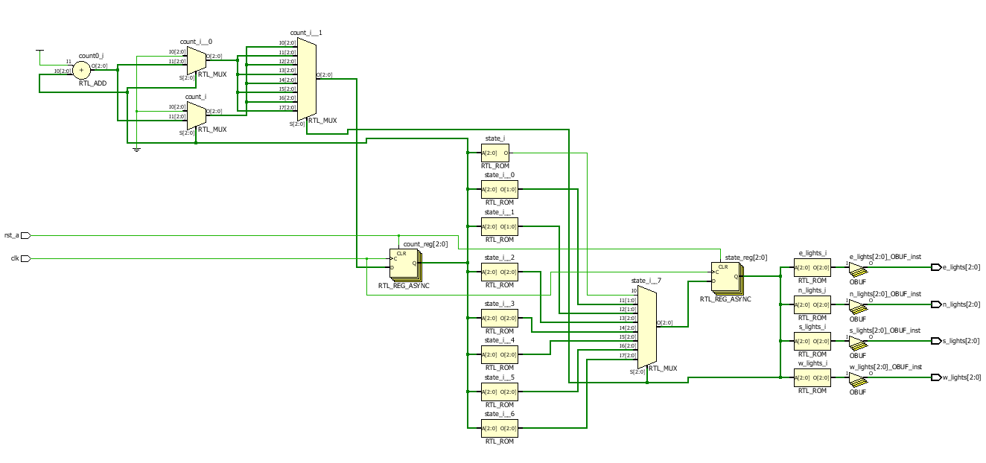

1. **TRAFFIC LIGHT CONTROLLER**

**CODE**

module traffic_control(north_road,east_road,south_road,west_road,clk,rst);

output reg [2:0] north_road,east_road,south_road,west_road; //Declaration of 4 roads

input clk;

input rst;

reg [2:0] state;

parameter [2:0] north = 3'b000;

parameter [2:0] north_y = 3'b001; //Declaration of yellow light state

parameter [2:0] east = 3'b010;

parameter [2:0] east_y = 3'b011; //Declaration of yellow light state

parameter [2:0] south = 3'b100;

parameter [2:0] south_y = 3'b101; //Declaration of yellow light state

parameter [2:0] west = 3'b110;

parameter [2:0] west_y = 3'b111; //Declaration of yellow light state

reg [2:0] count;

always @(posedge clk, posedge rst)

begin

if (rst)

begin

state = north;

count = 3'b000;

end

else

begin

case (state)

north :

begin

if (count == 3'b111) //Changes to yellow light state

begin

count = 3'b000;

state = north_y;

end

else

begin

count = count+3'b001; //Count's for 8 clock pulses

state = north;

end

end

north_y :

begin

if (count == 3'b011) //Road change

begin

count = 3'b000;

state = east;

end

else

begin

count = count+3'b001; //Count's for 4 clock pulses

state = north_y;

end

end

east :

begin

if (count == 3'b111) //Changes to yellow light state

begin

count = 3'b0;

state = east_y;

end

else

begin

count = count+3'b001; //Count's for 8 clock pulses

state = east;

end

end

east_y :

begin

if (count == 3'b011) //Road change

begin

count = 3'b0;

state = south;

end

else

begin

count = count+3'b001; //Count's for 4 clock pulses

state = east_y;

end

end

south :

begin

if (count == 3'b111) //Changes to yellow light state

begin

count = 3'b0;

state = south_y;

end

else

begin

count = count+3'b001; //Count's for 8 clock pulses

state = south;

end

end

south_y :

begin

if (count == 3'b011) //Road change

begin

count = 3'b0;

state = west;

end

else

begin

count = count+3'b001; //Count's for 4 clock pulses

state = south_y;

end

end

west :

begin

if (count == 3'b111) //Changes to yellow light state

begin

state = west_y;

count = 3'b0;

end

else

begin

count = count+3'b001; //Count's for 8 clock pulses

state = west;

end

end

west_y :

begin

if (count == 3'b011) //Road change

begin

state = north;

count = 3'b0;

end

else

begin

count = count+3'b001; //Count's for 4 clock pulses

state = west_y;

end

end

endcase

end

end

//Red light value='100', Yellow light value='010', Green light value='001'

always @(state)

begin

case (state)

north :

begin

north_road = 3'b001;

south_road = 3'b100;

east_road = 3'b100;

west_road = 3'b100;

end

north_y :

begin

north_road = 3'b010;

south_road = 3'b100;

east_road = 3'b100;

west_road = 3'b100;

end

east :

begin

north_road = 3'b100;

south_road = 3'b001;

east_road = 3'b100;

west_road = 3'b100;

end

east_y :

begin

north_road = 3'b100;

south_road = 3'b010;

east_road = 3'b100;

west_road = 3'b100;

end

south :

begin

north_road = 3'b100;

south_road = 3'b100;

east_road = 3'b100;

west_road = 3'b001;

end

south_y :

begin

north_road = 3'b100;

south_road = 3'b100;

east_road = 3'b100;

west_road = 3'b010;

end

west :

begin

north_road = 3'b100;

south_road = 3'b100;

east_road = 3'b001;

west_road = 3'b100;

end

west_y :

begin

north_road = 3'b100;

south_road = 3'b100;

east_road = 3'b010;

west_road = 3'b100;

end

endcase

end

endmodule

**TEST BENCH**

module traffic_control_test;

wire [2:0] n_lights,e_lights,s_lights,w_lights;

reg clk,rst;

traffic_control tt (n_lights,e_lights,s_lights,w_lights,clk,rst);

initial

begin

clk=1'b1;

forever #5 clk=~clk;

end

initial

begin

rst=1'b1;

#10 rst=1'b0;

#1000;

$stop;

end

endmodule

**SIMULATED OUTPUT**

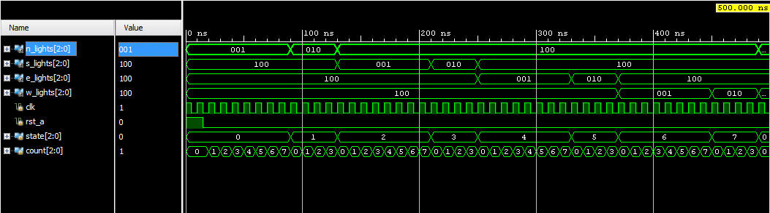

**2) FINDING THE DAY OF THE WEEK FROM A GIVEN DATE**

**CODE**

module sample(year,month,date,day,res);

input [15:0] year;

input [3:0] month;

input [4:0] date;

output [2:0] day;

output [7:0] res;

reg [5:0]yy;

assign res = (y(year)+century(year/100)+date+mon(month)-leap_year(year)); //Intermediate result(not required)

assign day = res%7; //Final answer

initial

begin

if(day == 2'd0)

$display("SUNDAY");

else if(day == 2'd1)

$display("MONDAY");

else if(day == 2'd2)

$display("TUESDAY");

else if(day == 2'd3)

$display("WEDNESDAY");

else if(day == 3'd4)

$display("THURSDAY");

else if(day == 3'd5)

$display("FRIDAY");

else if(day == 3'd6)

$display("SATURDAY");

else

$display("INVALID ");

end

function [14:0] y; //Generating year code

input [14:0]year;

begin

assign yy = year%100;

assign y = (yy+(yy/4))%7;

end

endfunction

function [3:0] mon; //Generating month code

input [3:0] month;

if(month == 4'd1)

mon = 3'd0;

else if(month == 4'd2)

mon = 3'd3;

else if(month == 4'd3)

mon = 3'd3;

else if(month == 4'd4)

mon = 3'd6;

else if(month == 4'd5)

mon = 3'd1;

else if(month == 4'd6)

mon = 3'd4;

else if(month == 4'd7)

mon = 3'd6;

else if(month == 4'd8)

mon = 3'd2;

else if(month == 4'd9)

mon = 3'd5;

else if(month == 4'd10)

mon = 3'd0;

else if(month == 4'd11)

mon = 3'd3;

else if(month == 4'd12)

mon = 3'd5;

else

$display("INVALID");

endfunction

function [3:0]century( input [15:0] year); //Generating century code

if(year == 5'd17)

century = 4'd7;

else if (year == 5'd18)

century = 4'd5;

else if (year == 5'd19)

century = 4'd3;

else if (year == 5'd20)

century = 4'd6;

else if (year == 5'd21)

century = 4'd4;

else if (year == 5'd22)

century = 4'd2;

else if(year == 5'd23)

century = 4'd0;

else

$display ("GIVE ANOTHER YEAR");

endfunction

function leap_year(input [15:0] year); //Checks if it is a leap year

begin

assign leap_year=(month == 4'd1 || month == 4'd2)?((year%400==1'b0 || year%4==1'b0)?1:0):0;

end

**TEST BENCH**

module sample_tb();

reg [15:0] year;

reg [3:0] month;

reg [4:0] date;

wire [2:0] day;

sample s1(year,month,date,day);

initial

begin;

#10year = 16'd1988;

#10month=4'd9;

#10date=5'd4;

#20year=16'd2019;

#20month=4'd04;

#20date=5'd4;

#30year=16'd2167;

#30month=4'd02;

#30date=5'd6;

end

endmodule

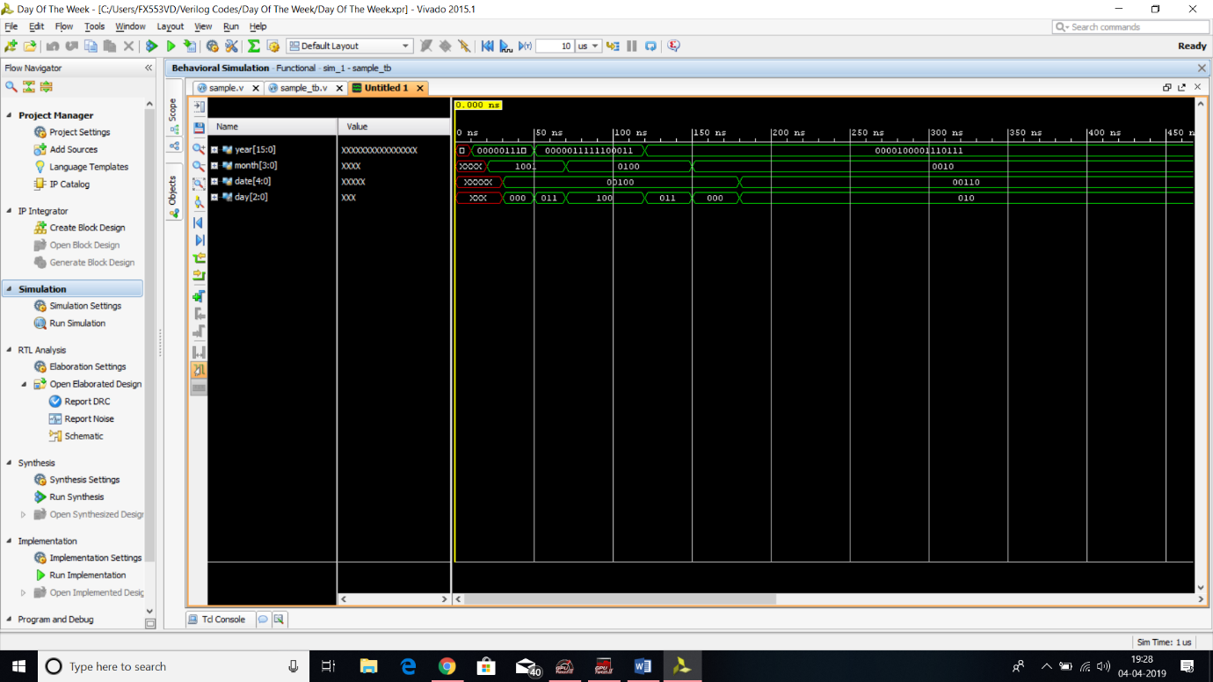**SIMULATED OUTPUT**

**CONCLUSION AND APPLICATIONS**

* **Traffic controller**

As we move forward towards being a developed country, there are many parameters that increase in amount and cause inconvenience. One such very obvious parameter is Traffic. It has increased exponentially and has hence caused uncountable number of accidents. It is therefore very important to control it efficiently. The code above does the same indicating different lights for each road in the junction being north, south, east, west

* **Calendar**

From aiding us while setting up an appointment to helping us keep a reminder for an occasion, calendar provides us with the facility to keep on track and know future dates. It helps us to be more productive and picky of the time we spend doing nothing. The calendar code written is based on Gregorian Calendar that gives the day as output for any date between 1700s to 2300s.